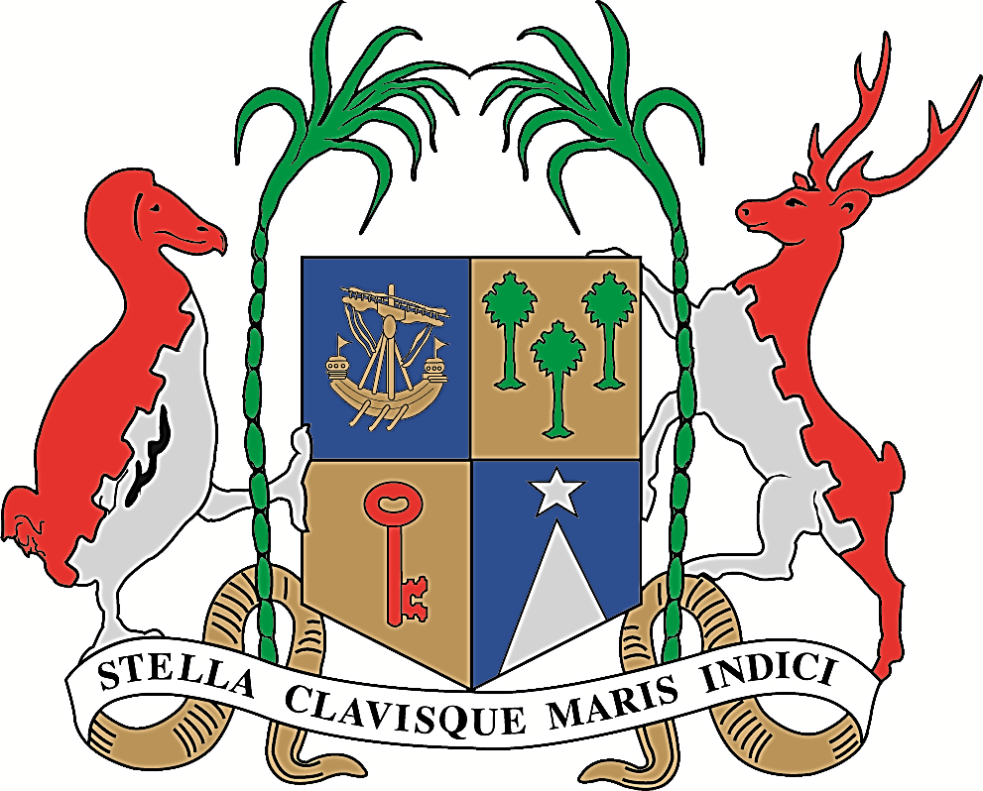

REPUBLIC OF MAURITIUS
MINISTRY OF FOREIGN AFFAIRS, REGIONAL INTEGRATION
AND INTERNATIONAL TRADE

Communiqué

The Ministry of Foreign Affairs, Regional Integration and International Trade of the Republic of Mauritius has taken cognizance of the recent political developments that have occurred in the Gulf region recently.

The Ministry of Foreign Affairs, Regional Integration and International Trade, pursuant to its stand of maintaining cordial relations with all countries of the Gulf region, favours dialogue between the countries involved in the interest of peace and stability in the region and in the world.

Ministry of Foreign Affairs, Regional Integration
and International Trade
Port Louis
06 June 2017

