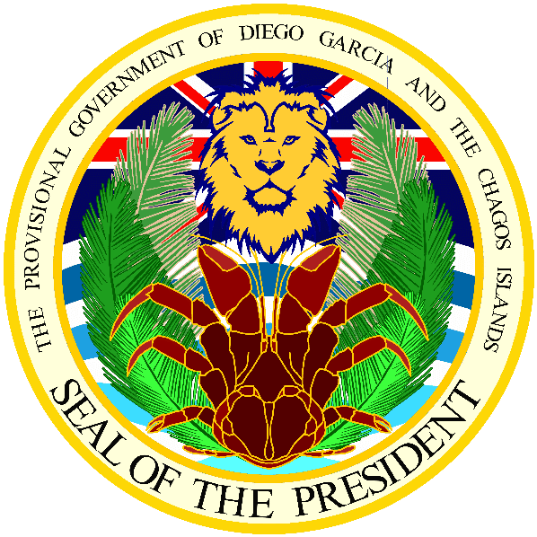

Office of the President
12th July 2016
Press Release
For Immediate Release
President Allen Vincatassin statement
Chagossians uphold British sovereignty over their homeland
‘In a recent correspondence the Prime Minister David Cameron has assured Mr. Henry Smith MP (Crawley) and myself that he has made it clear to the Prime Minister of Mauritius that UK is sovereign over the Chagos islands.
Today I got to meet with the Commissioner of the British Indian Ocean Territory (Chagos islands) Dr Peter Hayes at the Foreign & Commonwealth Office, under the advice of the Prime Minister. We discussed about the decision process of the pilot resettlement project and the implementation of the Marine Protected Area.
I have informed the Commissioner that most Chagossians acknowledge only British sovereignty over their homeland and that they want to be resettled only by the UK, as the Chagos islands is a British Overseas Territory.
We want to voice out the inhuman treatment to which we were subjected to on our arrival in Mauritius, when we were exiled between 1971 and 1973, from our homeland. We have been treated as destitute entities by the Mauritians who were not at all concerned by our fate. We had to silence our inner torment and accepted what was imposed upon us. The Mauritian government did nothing to prevent this human tragedy, instead was party to a type of ethnic cleansing. In 1982, the Mauritian Government forced us to abandon our right of returning to our homeland. Our land was snatched; our identity baffled as well and the ambiguity of our lives are still felt by our young children when we are to tell them about their roots.
In the light of all this Chagossians do not wish to suffer any more prejudices and inhuman treatment, we want to return to our homeland in dignity with the help and support of the UK.I have informed the Commissioner that there should be no treaty given to the Mauritian Government over the future of the Chagos islands, without prior discussion with the Chagossian people.’

Please contact us if you need more info:
Tel:07427198804(9:30am-2:00pm)
presidentallenvincatassin@gmail.com

